Ukrainian Social Investment Fund

PROJECT: EU4Skills: Modernisation of Vocational Education and Training Infrastructure in Ukraine

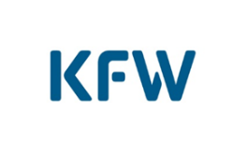

ENVIRONMENTAL AND SOCIAL IMPACT ASSESSMENT
for Subproject No. 21-23-2 “Zaporizhzhia Polytechnical Centre for Vocational Education, Zaporizhzhia, Zaporizhzhia region/EU4Skills”
Version No 1 dated 31.10.2021,
Approved by USIF’s Executive Committee (Minute No. 43 dd 08.11.2021)
Version No 2 dated 29.11.2021
Approved by KfW (letter dated 06.12.2021)

Kyiv-2021

 | List of Abbreviations……………………………………………….. | 3
 | Introduction………………………………………………………… | 4
1 | General information about the Subproject………………………. | 4
2 | Description of the facility and the planned activities…………….. | 4
2.1 | Brief physical-geographical and climatic characteristics of the area………………………………………………………………….. | 4
2.2 | Description of the facility…………………………………………. | 6
2.3 | Description of the planned activities…………………………….. | 8
3 | List of Ukrainian laws, standards, policies, rules and regulations in the field of environmental and social management …………. | 9
3.1 | Description of relevant regulations and legal requirements of Ukraine……………………………………………………………. | 11
3.2 | Description of relevant international standards and requirements………………………………………………………. | 13
4 | Environmental and Social Impact Assessment…………………. | 15
5 | Environmental and Social Management Plan………………….. | 28
6 | Stakeholder Engagement, Information Disclosure and Processing of Stakeholder Grievances and Appeals………………………… | 43
 | Annex 1 Subproject Screening Criteria. Checklist to complete and save………………………………………………………………… | 48
 | Annex 2 Minutes of public consultation dated 26 October 2021………………………………………………………………… | 53

KfW | German Development Bank KfW
SEI | State educational institution
MoES | Ministry of Education and Science of Ukraine
GM | Grievances Mechanism
EIA | Environmental impact assessment
RSA | Regional state administration
ESIA | Environmental and social impact assessment
SEP | Stakeholder engagement plan
ESMP | Environmental and Social Management Plan
DED | Design and estimate documentation
VET | Vocational education and training
USIF RO | Regional Office of the Ukrainian Social Investment Fund
ESS | World Bank Environmental and Social Standards
SP | Subproject
USIF | Ukrainian Social Investment Fund
USIF CO | Ukrainian Social Investment Fund Central Office
List of Abbreviations
Introduction
The Environmental and Social Impact Assessment (hereinafter referred to as ESIA) has been carried out in order to identify and assess the potential environmental and social impacts and to develop suitable mitigation measures, which are documented in an Environmental and Social Management Plan (hereinafter referred to as ESMP).
The ESIA has been developed in accordance with the provisions of the World Bank Environmental and Social Standards (hereinafter referred to as WB ESS) and taking into account the requirements of national environmental legislation, the actual state of the natural and social environment of the worksite and the technical condition of the facility.
- General information about the Subproject
The Government of Ukraine and the Commission of the European Communities entered into an agreement on 17 December 2018 to fund "EU4Skills: Better Skills for Modern Ukraine" activities, which will be partly implemented and financed through the German Development Bank KfW (hereinafter referred to as KfW). Based on this Agreement, as well as on the Contribution Agreement of 02 October 2019 between the European Union represented by the European Commission ("European Commission") and KfW (hereinafter referred to as Contribution Agreement), a Financial and Project Grant Agreement No. ENI/2019/410-215 of 30 July 2020 (hereinafter referred to as Grant Agreement) was signed between KfW and the Ukrainian Social Investment Fund (USIF) for the implementation of the Project "EU4Skills: Modernisation of Vocational Education and Training Infrastructure in Ukraine" (hereinafter referred to as Project). This Project concerns the modernisation of the vocational education and training (VET) system in Ukraine. It will focus on the renovation and modernisation of VET schools and the purchase of equipment.
Objective of the Project: To create a modern vocational education and training infrastructure that increases the attractiveness of vocational education and training among students and creates a basis for effective education, focusing on skills in occupations that are in demand on the Ukrainian labour market.
Project description: 15 vocational education and training schools will receive investments in the form of energy-efficient renovation of their educational facilities and provision of the necessary equipment for the educational process.
Geographical region of the Project: Vinnytsia, Zaporizhzhia, Lviv, Mykolaiv, Poltava, Rivne, Chernivtsi regions.
2. Description of the facility and the planned activities
2.1. Brief physical-geographical and climatic characteristics of the area
The city of Zaporizhzhia is a large industrial city in south-eastern Ukraine, the administrative centre of Zaporizhzhia region. The area of the city is 331 square kilometres. The population as of 01 January 2021 is 722,713 people. The prevailing wind directions throughout the year are easterly, north-easterly, and partly north-westerly. The predominant wind directions during the year are north, northeast, east. The average annual wind speed is 3.8 m/sec. The average annual air temperature is 9.0°C, the average air temperature in July is 22.9°C, in January is -4.9°C.
The subproject site is located in the northern part of Zaporizhzhia, on 2-B Perspektyvna Street.
The terrain is flat and planned. No unfavourable physical and geological processes and phenomena are observed within the site. There are no nature reserve sites in the area of the worksite.
The transport scheme of the existing roads allows construction equipment to access the Perspektyvna Street site, with an asphalt concrete surface.
Figure 1 Location of the worksite on the map
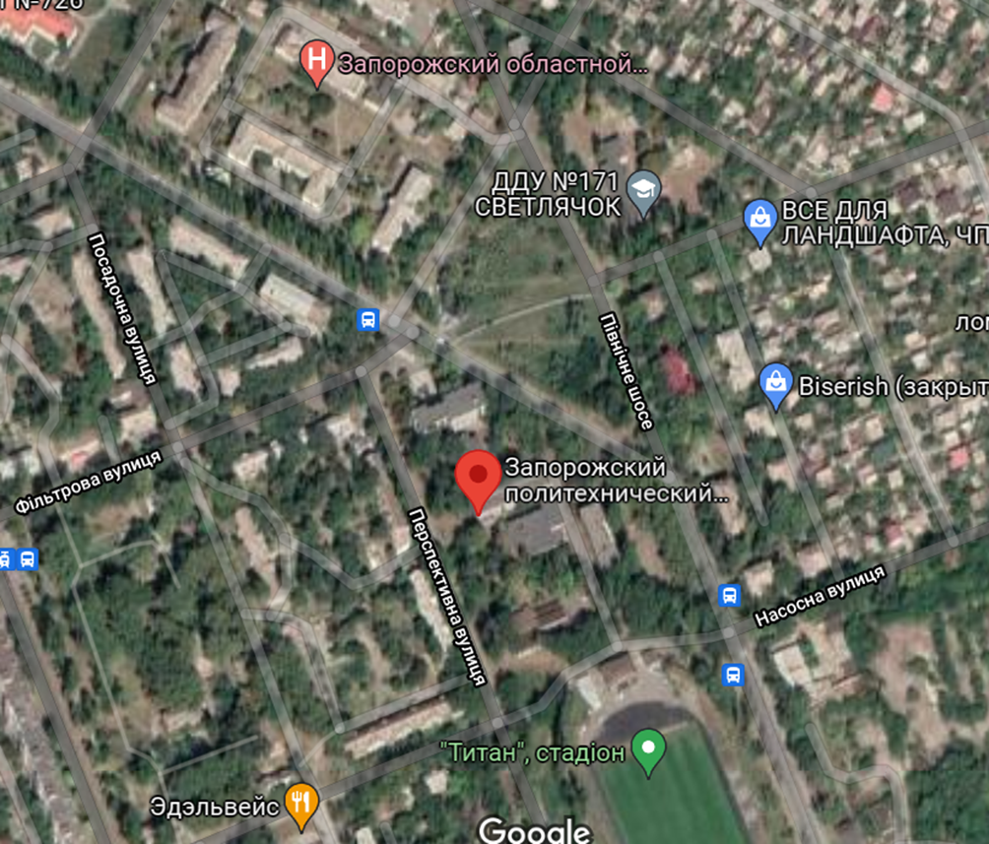
The worksite area is borders with:
From the North – Perspektyvna Street driveway, across Perspektyvna Street driveway is park, territory of the Zaporizhzhia regional anti-tuberculosis clinical dispensary, residential buildings;
From the East – Pivnichne Highway driveway, across Pivnichne Highway driveway is public transport stops, residential buildings and commercial development;
From the West – Filtrova and Perspektyvna Streets driveway, across Filtrova and Perspektyvna Streets driveway are Primary Health Care Centre No. 4 (distance up to 100 m) and residential buildings (distance up to 100 m), garages;
From the South – Nasosna Street driveway, across Nasosna Street driveway is stadium “Titan”, on the VET school territory are two buildings: dormitory and canteen (not in operation).

2.2. Description of the facility
The State Educational Institution "Zaporizhzhia Polytechnical Centre for Vocational Education" (Zaporizhzhia PCVE, Recipient) is a state vocational education and training institution, that provides training for skilled workers in seven professions and three specialties of junior bachelor.
Currently the number of students is 481. The number of VET school staff is 80 people, including 45 people of teaching staff.
The Zaporizhzhia PCVE trains qualified personnel in the following professions: welder, fitter-repairman, electrician for repair and maintenance of electrical equipment, cook, confectioner, electrician for repair and maintenance of computers, mechatronics technician.
The institution has a license to conduct educational activities in the field of vocational education № 133l dated 06 February 2015, and a license to conduct educational activities in the field of professional pre-higher education № 986-l dated 21 November 2019. both licenses are issued by the Ministry of Education and Science of Ukraine, issued by the Ministry of Education and Science of Ukraine.
The land plot owner is the State of Ukraine represented by Zaporizhzhia Regional State Administration with the right of using by the Zaporizhzhia PCVE for construction and maintenance of buildings of educational institutions (state certificate on the right of permanent use of land series ЯЯ № 121655 dated 05 June 2007, extract from the State Register of Real Property Rights on registration of other real right № 83086499 dated 22 March 2017).
The complex of building belongs to the MoES (extract from the State Register of Rights to Immovable Property on registration of ownership rights 26949905 issued on 18 September 2014) with the right of operational management by the Zaporizhzhia PCVE (MoES Order No. 575 dated 01 June 2018 "On assignment of state property to the State Educational Institution "Zaporizhzhia Polytechnical Centre for Vocational Education".

To start the construction work, the Employer of Construction (Zaporizhzhia PCVE) will apply to the Ukrainian Architectural and Construction Control authorities for a permit to start the construction work.
Upon completion, the Employer of Construction (Zaporizhzhia PCVE) will submit to the State Architectural and Construction Inspectorate of Ukraine a set of documents to obtain a Certificate of Operational Acceptance of the completely constructed facility.
Facility characteristics: a building with a cascading configuration, which consists of four parts. The premises are shown on the technical passport A-1,2,3 built in 1965, A'-1,2, D-4 built in 1983-1984. The first part is a rectangular four-storey building with a basement (classrooms and workshops). The second part is a rectangular extension, two-storey (classrooms and workshops). The third part is a rectangular extension, three-storey (classrooms and workshops). The fourth part is a rectangular extension, two-storey (classrooms and workshops), connected by passages.
The total area of ​​educational buildings - 5800 sqm; the area required for repair is 636.4 sqm.
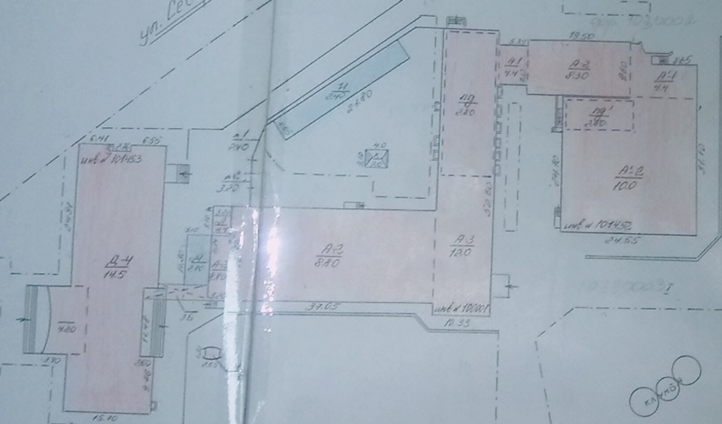
The structural part of the building is walled with load-bearing external and internal walls.
Walls - brick, partition walls - brick, slabs - reinforced concrete slabs, floors - concrete, linoleum, windows - metal-plastic, doors - wooden, metal-plastic and metal, roof over the building is straight, multilevel.
Engineering networks: centralised heating, centralised water supply and wastewater disposal.
The condition of the main structural elements is satisfactory and the building requires modernisation.
Vegetation in the surrounding area: grass, bushes and trees.
Inspection of the facility for the presence of asbestos.
As a result of asbestos surveys conducted on August 3, 2021 in the Zaporizhzhia PCVE, five samples of materials used in the construction of the structure were selected. The asbestos surveys conducted in the laboratory of Kharkiv National University of Municipal Economy named after O.M. Becketov showed the following results:
1) asbestos-containing materials are available in the workshop of manual, semi-automatic, automatic, argon-arc welding and plasma cutting: asbestos-cement plates used as fire-resistant partitions, asbestos-cement materials from which fire-resistant chairs are made, insulating material on the ventilation duct (asbestos cord) chrysotile content of 40-45 wt. %.
2) asbestos-containing materials are available in the laboratory of cooks and confectioners - asbestos cord, which is an insulating material on the ventilation duct (hood). The chrysotile content is 55-60 wt. %.
3) materials are characterized by low and medium risk of release of fibers into the environment - the total score of the material characterizing the type of product, the degree of material damage, surface treatment and type of asbestos, is: asbestos fireproof partition - 5 points, asbestos fireproof chair - 7 points, asbestos cord on the ventilation duct in the workshop of manual, semi-automatic, automatic, argon-arc welding and plasma cutting - 7 points, asbestos cord on the ventilation duct in the laboratory of cooks and confectioners - 8 points, as well as the average risk of removing asbestos-containing materials subject to health and safety requirements.
Requirements and recommendations for the ACM handling, identified by the results of the surveys, are given in table 4.4. Section 4, as well as in ESMP in Section 5.
2.3. Description of the planned activities
As part of the subproject implementation (hereinafter referred to as SP) the following is previously envisaged:
- Internal repair of training laboratories and workshops by professions (replacement of windows with internal and external slopes, interior decoration of premises with replacement of utilities (electricity, electric lighting, plumbing and sewerage, heating, ventilation within the premises), commissioning):
- welder (additional equipment). The workshop is located on the first floor of building A-1,2,3, with an area of 179.4 sqm. The room number according to the technical passport is 60;
- fitter-repairman (additional equipment). The workshop is located on the second floor of building A-1,2,3, with an area of 85 sqm. The room number according to the technical passport is 87;
- electrician for repair and maintenance of electrical equipment (additional equipment). The workshop is located on the second floor of building A-1,2,3, with an area of 85.2 sqm and 63,5 sqm. The room numbers according to the technical passport are 81 and 71;
- cook, confectioner. The workshop is located on the first floor of building D-4, with an area of 85.1 sqm. Room numbers according to the technical passport are 6, 7;
- electrician for repair and maintenance of computers. The workshop is located on the third floor of building A-1,2,3, with an area of 71.2 sqm. Room numbers according to the technical passport are 104, 105;
- mechatronics technician. The workshop is located on the fourth floor of building D-4, with an area of 67 sqm. The room numbers according to the technical passport are 76 and 77.
2) updating of training laboratories and workshops equipment.
3) removal of revealed asbestos materials prior to other activities. Removal must be carried out by trained and competent employees in accordance with the environmental and labor safety requirements. Destruction of the material is not allowed: breaking, sawing, cutting, drilling, etc. All activities regarding ACM must be performed using appropriate personal protective equipment (protective shoes and helmet, gloves, mask with filters and overalls).
3. List of Ukrainian laws, standards, policies, rules and regulations in the field of environmental and social management
- Labour Code
- Land Code
- Commercial Code
- Civil Protection Code
- Forestry Code (Woodland Code)
- Water Code
- Law of Ukraine "On Environmental Protection"
- Law of Ukraine "On Environmental Impact Assessment" (not applicable as the construction facility does not belong to the types of planned activities that have a significant impact on the environment)
- Law of Ukraine "On Protection of Atmospheric Air"
- Law of Ukraine "On Waste"
- Law of Ukraine "On Amendments to Certain Legislative Acts of Ukraine Regarding Improvement of the Mechanism of Legal Regulation and Strengthening Liability in the Field of Waste Management"
- Law of Ukraine "On Scrap Metal"
- Law of Ukraine "On the Fundamentals of Urban Development"
- Law of Ukraine "On Land Protection"
- Law of Ukraine "On Land Management"
- Law of Ukraine "On Architectural Activity"
- Law of Ukraine "On Regulation of Urban Development Activities"
- Law of Ukraine "On Labour Protection"
- Law of Ukraine "On Citizens' Appeals"
- Law of Ukraine "On Information"
- Law of Ukraine "On Access to Public Information"
- Law of Ukraine "On Ensuring Sanitary and Epidemiological Welfare of the Population"
- Law of Ukraine "On Local Government in Ukraine"
- Law of Ukraine "On Improvement of Residential Settlements"
- Law of Ukraine "On the Natural Reserve Fund of Ukraine"
- Law of Ukraine "On Plant Life"
- Law of Ukraine "On Animal Life"
- Order of the Cabinet of Ministers of Ukraine No. 996 of 03 November 2010 "On Ensuring Public Participation in the Formation and Implementation of Government Policy"
- Order of the Cabinet of Ministers of Ukraine No. 1106 of 25 October 2017 "On the Implementation of the Association Agreement between Ukraine, on the one hand, and the European Union, the European Atomic Energy Community and their Member States, on the other hand"
- Order of the Ministry of Social Policy No. 1050 of 23 July 2017 "On Approval of the Minimum Occupational Safety Requirements for Temporary or Mobile Construction Sites"
- Order of the Ministry of Social Policy No. 1804 of 29 November 2018 "On Approval of the Minimum Safety and Health Requirements for the Use of Personal Protective Equipment by Employees at Work"
- SCN A 2.2.-3-2014 Composition and Content of Construction Project Documentation
- SCN A.2.2-1-2003 On Environmental Impact Assessment
- SCN А.3.1 – 5:2016 Construction Management
- SCN В. 1.1-7:2016 Construction Fire Safety. General Requirements
- National standard of Ukraine DSTU 8855:2019 Buildings and Structures. Determination of the Class of Impact (Liability)
- SCN А.3.2-2-2009. Occupational Health and Safety in the Construction. General Provisions
- Order of the Ministry of Public Health on approval of State sanitary rules and regulations “On the safety and protection of workers from the harmful effects of asbestos and asbestos-containing materials” No 762 of 01.10.2012
- SCN V.2.4-2-2005. Landfills for municipal solid waste. Basic design principles
- Decree of the Cabinet of Ministers of Ukraine on approval Regulation on the control of transboundary movements of hazardous wastes and their disposal / disposal and the Yellow and Green lists of wastes No 1120 of 13.07.2000
- Directive 2009/148/EC of the European Parliament and of the Council of the 30 November 2009 on the protection of workers from the risks related to exposure to asbestos at work
https://eur-lex.europa.eu/LexUriServ/LexUriServ.do?uri=OJ:L:2009:330:0028:0036:EN:PDF
- Practical guidelines for the information and training of workers involved with asbestos removal or maintenance work
https://osha.europa.eu/en/legislation/guidelines/practical-guidelines-for-the-information-and-training-of-workers-involved-with-asbestos-removal-or-maintenance-work
- Guidelines for Environmental, Social and Climate Aspects Assessment and Management of 01 February 2021
- World Bank Social and Environmental Standards of 01 October 2018
- General and Sector Guidelines for Environment, Health and Safety
- Fundamental Conventions of the International Labour Organisation (ILO)
https://www.ilo.org/global/standards/introduction-to-international-labour-standards/conventions-and-recommendations/lang--en/index.htm#:~:text=The%20ILO%20Governing%20Body%20has,forced%20or%20compulsory%20labour%3B%20the
- Convention on Access to Information, Public Participation in Decision-making and Access to Justice in Environmental Matters
- Council Directive 92/57/ EEC on Minimum Health and Safety Requirements for Temporary or Mobile Construction Sites
- Convention on Environmental Impact Assessment in a Transboundary Context
- Joint Convention on the Safety of Spent Fuel Management and on the Safety of Radioactive Waste Management
3.1. Description of relevant regulations and legal requirements of Ukraine
The Law of Ukraine "On Environmental Protection" defines the legal, economic and social basis for the organisation of environmental protection.
The Law of Ukraine "On Environmental Impact Assessment" of 23 May 2017 establishes the legal and organisational framework for environmental impact assessment and ensures that Ukraine meets its international obligations under the Convention on Environmental Impact Assessment in a Transboundary Context and the Convention on Access to Information, Public Participation in Decision-making and Access to Justice in Environmental Matters. Parts 2 and 3 of Article 3 of this Law set out a list of activities that require an EIA.
The main law that regulates construction activities is the Law of Ukraine "On Regulation of Urban Development Activities". This law specifies which documents must be prepared for different types of construction projects and how such documents must be reviewed from time to time.
The procedure for preparing documentation that deals with environmental impact assessment (EIA) is set out in the State Construction Norms SCN A.2.2-1-2003 "On Environmental Impact Assessment".
The construction facility is not included in the types of planned activities and facilities that may have a significant impact on the environment and is not subject to an environmental impact assessment in accordance with the Law of Ukraine "On Environmental Impact Assessment". But SCN A.2.2-3-2014 requires a mandatory section on “environmental impacts (on land, water and other resources) and measures for their minimization, mitigation and compensation” for design of all objects. SCN A.3.1-5:2016 includes a set of the requirements to the on-site ESH issues (Construction site organization project) in the design and estimate documentation as well a set requirement to the Contractor`s Project of Work Execution (the document same purpose and similar to C-ESMP). SCN A.3.2-2:2009 defines requirements to occupational safety on construction sites.
Ukraine's labour protection legislation consists of the Law of Ukraine "On Labour Protection", the Labour Code, the Law of Ukraine "On Compulsory State Social Insurance" and the laws and regulations adopted pursuant to it.
State policy in the field of labour protection is based on the principle of the priority of life and health of employees and the full responsibility of the employer for creating appropriate, safe and healthy working conditions.
In particular, the provisions of the Law of Ukraine "On Labour Protection" define the rights of employees to labour protection during work (Article 6), benefits and compensation for difficult and harmful working conditions (Article 7), provision of protective clothing, other personal protective equipment, detergents and disinfectants (Article 8) and mandatory training in occupational health and safety for employees (Article 18). In order to ensure compliance with the above provisions, the employer shall organise the process of labour protection management, including, but not limited to, by developing and approving regulations, instructions and other labour protection acts, establishing a health and safety service and appointing persons responsible for specific health and safety issues, monitoring the employee's compliance with technological processes, rules for handling machines, mechanisms, equipment and other means of production, use of collective and personal protective equipment and the performance of work in accordance with health and safety requirements.
Pursuant to Article 19, the employer shall finance labour protection measures.
Order of the Ministry of Social Policy of Ukraine No. 1804 of 29 November 2018 approved the Minimum Safety and Health Requirements for the use of personal protective equipment by employees at the workplace, which establish general requirements for personal protective equipment (hereinafter referred to as PPE) used by employees during the work process.
Order of the Ministry of Social Policy of Ukraine No. 9 of 29 January 1998 approved the Regulation on the development of instructions on labour protection, which sets out requirements for the content, structure and presentation of instructions on labour protection, operating within the enterprise, institution or organisation.
Order of the State Committee of Ukraine for the Supervision of Labour Protection No. 15 of 26 January 2005 approved the Standard Regulation for training and testing knowledge of labour protection issues, which establishes the procedure for training and testing knowledge of labour protection for officials and other employees at work, as well as pupils, cadets, trainees and students in educational institutions during their work and vocational training.
Order of the Ministry of Emergencies of Ukraine No. 67 of 25 January 2012 approved the General requirements for employers to ensure labour protection of employees, which establish the creation of safe and harmless working conditions by proper arrangement of workplaces and production, sanitary facilities and other premises in the enterprise, institutions, organisation, safe use of work equipment by employees, providing training and engagement of employees in resolving labour protection issues and regulating labour protection relations between enterprises when employees of other enterprises are involved in work.
SCN А.3.2-2-2009. Occupational Health and Safety in the Construction. Occupational Health and Safety Requirements during construction and installation works. These standards apply to general construction and special construction works during new construction, expansion, reconstruction, technical refurbishment, major repairs and restoration of buildings and structures. In general, the field of occupational health and safety management is governed by many regulations: rules, norms, regulations, provisions, standards, instructions, etc.
3.2. Description of relevant international standards and requirements
The Guidelines for Environmental, Social and Climate Impact Assessment and Management of 01 February 2021 describe the principles and procedures for environmental, social and climate impact assessments in the preparation and implementation of KfW-financed projects, define a common mandatory basis for using environmental, social and climate standards in planning, assessment, implementation and monitoring of FC measures, increases transparency, predictability and accountability in decision-making processes in conducting a comprehensive internal examination of environmental and social aspects and assessment of climate aspects.
As of 01 October 2018, the World Bank's Social and Environmental Principles (hereinafter referred to as SEP) apply to all new investment projects financed by the World Bank.
The SEP allow the World Bank and Borrowers to improve the management of social and environmental risks of projects and improve development outcomes.
The SEP include:
The concept of sustainable development;
The World Bank's Social and Environmental Policy for Investment and Project Finance;
Environmental and Social Standards;
The Bank's Directive: Environmental and Social Directive on Investment Project Finance;
The Bank's Directive on Managing the Risks and Impacts on Disadvantaged or Vulnerable Individuals or Groups.
The World Bank's list of Environmental and Social Standards (hereafter referred to as ESS):
ESS 1: Assessment and Management of Social and Environmental Risks and Impacts;
ESS 2: Employees and Working Conditions;
ESS 3: Efficient Use of Resources and Prevention of Environmental Pollution;
ESS 4: Community Health and Safety;
ESS 5: Land Alienation, Restriction of Land Use Rights and Forced Relocation;
ESS 6: Conservation of Biodiversity and Balanced Management of Living Natural Resources;
ESS 7: Indigenous Peoples/Historically Vulnerable Traditional Local Communities in Sub-Saharan Africa;
ESS 8: Cultural Heritage;
ESS 9: Financial Intermediaries;
ESS 10: Stakeholder Engagement and Information Disclosure.
General and Sector Guidelines for Environment, Health and Safety.
Taking into account the characteristics of the SP and the potential social and environmental impacts of its implementation, the following ESS are applied during the implementation of the SP:
- ESS 1: Assessment and Management of Social and Environmental Risks and Impacts applies to the assessment, management and monitoring of social and environmental risks and impacts at each stage of the SP.
- ESS 2: Employees and Working Conditions applies to manage occupational health and safety issues, as well as to create a safe and healthy working environment during the implementation of the SP.
- ESS 3: Efficient Use of Resources and Prevention of Environmental Pollution applies to manage waste, including hazardous waste, and regulate the issue of environmental pollution: air, soil, and water.
- ESS 4: Community Health and Safety applies to the health and safety of affected communities during the life cycle of the SP, including those that may be vulnerable due to their particular circumstances, citizen and traffic safety during construction works, management of hazardous materials during construction works (including the management of asbestos-containing wastes).
- ESS 10: Stakeholder Engagement and Information Disclosure applies to ensuring a systematic approach to stakeholder engagement, maintaining constructive stakeholder relations, ensuring stakeholder views are taken into account, disclosing relevant project information and providing a transparent, clear and accessible mechanism for responding to grievances and appeals.

List of ESS that will not be applied during the implementation of the Project:
- ESS 5: Land Alienation, Restriction of Land Use Rights and Forced Relocation does not apply because the SP does not provide for land alienation, restriction of land use rights and forced relocation.
- ESS 6: Conservation of Biodiversity and Balanced Management of Living Natural Resources does not apply because the SP identifies no impacts on biodiversity and sustainable management of living natural resources, nor, the conservation of key ecological functions of habitats, including forests and the biodiversity they support, on the management of primary reproduction and harvesting of living natural resources.
- ESS 7: Indigenous Peoples/Historically Vulnerable Traditional Local Communities in Sub-Saharan Africa does not apply because the SP's implementation area does not include the indigenous peoples described in this ESS.
- ESS 8: Cultural Heritage does not apply because SP activities do not affect cultural heritage (tangible and intangible heritage), no reconstruction of cultural/historical heritage buildings (or buildings that are located in the protection zone of cultural/historical heritage objects).
- ESS 9: Financial Intermediaries does not apply because the SP does not provide for the involvement of financial intermediaries.
Taking into account the fact that Ukrainian legislation does not prohibit the use of Chrysotile (white asbestos), USIF will comply with the following requirements that meet the ESS:
1. The SP prohibits the use of materials containing asbestos.
2. Asbestos detection, sampling, mass sample analysis, health and safety issues, reporting and disposal of asbestos-containing materials will be handled in accordance with detailed recommendations and methodologies that meet KfW and ESS requirements and have been previously developed for USIF as part of the USIF VI project implementation by a qualified international asbestos management expert.
3. Apply the requirements of current Ukrainian legislation and international standards on the transportation and disposal of asbestos-containing materials.

4. Environmental and Social Impact Assessment
In order to comply with the provisions of the ESS and in order to implement the Environmental and Social Impact Assessment (hereinafter referred to as ESIA), the SP screening was carried out on 20 May 2021 as shown in Annex 1.
Based on the results of the screening, the potential environmental and social impacts of the planned SP activities have been revealed.
The identified environmental and social impacts are assessed in accordance with the provisions of the Guidelines and the ESS according to the following criteria:
- Location of the SP;
- Scale;
- Recoverability;
- Temporal impacts (temporality or permanence);
- Manageability;
- The nature and extent of potential impacts;
- Compliance with the requirements of national legislation and the provisions of the ESS and Guidelines.
As part of the impact assessment, the amount of risk (materiality of impact) is calculated by multiplying the probability indicators of the risk occurring and its consequences.
The level of impact is determined by examining a number of factors in terms of: location, scale, manageability, recoverability, timing of impacts and compliance with the requirements of national legislation and standards, and the like.

Table 4.1 Level of Impact
Category of impact | Level | Definition
Particularly threatening | 4 | Long-term impact, large scale impact on important sites (e.g. nature conservation areas, national parks, etc.), significant recovery time (more than 10 years), non-compliance with the requirements of legislation, standards, regulations, etc.
Significant | 3 | Severe environmental and social impacts with long- to medium-term impacts, average recovery time (5 to 10 years), probability of non-compliance with environmental regulations
Moderate | 2 | Short- to medium-term impact, fairly rapid and full recovery (1 to 5 years), probability of short-term and minimal non-compliance with specific provisions of the standards
Low | 1 | Low environmental and social impact, full compliance with legislation, standards, and the like, full recovery in less than a year without any interventions

The risk probability level is determined by assessing the probability of a particular risk occurring.

Table 4.2 Level of Probability
Probability of risk occurring | Level | Definition | Frequency
Almost inevitable | 4 | Will occur under normal operating conditions | Very often (long-term high probability)
Probably | 3 | Likely to occur under normal operating conditions | Often (regular probability)
Unlikely | 2 | Unlikely, but may occasionally occur under normal operating conditions | Isolated cases
Very unlikely | 1 | It is extremely unlikely to occur under normal operating conditions, but it may occur in exceptional circumstances | Exceptional cases

Significance of impact (SI) is calculated by multiplying the impact (I) by the probability (P):
SI = I x P

Table 4.3 Significance of Impact
Level (I x P) | Significance
> 12 | Critical
8-12 | High
4-6 | Average
1-3 | Low

The following table describes the potential risks and impacts of the SP in the pre-implementation, construction and operational phases and calculates their significance.

Table 4.4 Calculation of significance of identified potential risks and impacts
Potential impact | Mitigation measures | Level of impact | Probability of impact | Significance of impact
Pre-implementation phase of the SP
Neglect of environmental and social aspects in the preparation of the DED | - The design organisation will develop an EIA section as part of the DED, a section of the Construction Management Plan which will contain fire safety measures and a health and safety plan.  - The DED will ensure that the needs of people with limited mobility are taken into account and that environmentally friendly, accessible and optimum design solutions are used.  - Asbestos survey, sampling of construction materials and structures, laboratory analysis of these samples for the content and condition of asbestos, providing school with the relevant recommendations | 3 | 1 | 3
Non-compliance with the stakeholder engagement requirements | - The USIF has developed a Stakeholder Engagement Plan (hereinafter referred to as SEP), which will be made publicly available for public discussions.  - The public will be informed about the progress of the SP implementation/  - A grievances mechanism (hereinafter referred to as GM) has been developed and made public.  - SH survey has been organised.  - Potential disruptions and their duration should be identified and communicated. | 2 | 2 | 4
Violation of the rules on notification to the relevant local authorities and the public and the procedure for obtaining building permits  Non-compliance with national permit requirements | - the local State Architecture and Construction Control authority will be notified of the planned activities.  - all necessary permits will be obtained.  - the public will be notified of the planned activities. | 4 | 1 | 4
Construction phase
Non-compliance with occupational health and safety and fire safety requirements | - All works will be carried out safely and with discipline to minimise impact on the public and environment.  - Workers' personal protective equipment will comply with international practices.  - The site will have stands with information on basic work practices, health and safety at work and fire safety.  - Equipment and machinery will be managed by trained and experienced personnel to reduce the risk of accidents.  - The WHO recommendations and government measures to protect against COVID-19 will be implemented and enforced: use of disposable masks, gloves, hand hygiene, room ventilation, non-admission to the workplace of persons with signs of illness, keeping a distance, undergoing vaccination procedures, if possible, etc, COVID-19 cases among the employees will be recorded and the relevant authorities will be informed. A responsible person from the Contractor will be appointed for compliance with the above measures.  - The Contractor shall ensure that the equipment, tools and machinery are in proper working condition.  - The Contractor shall provide briefings, training and knowledge tests on occupational health, safety and fire safety of its personnel (including the provision of pre-medical training and rules of conduct in the event of accidents).  - A fire safety officer will be appointed.  - The construction site shall be equipped with fire-fighting equipment, namely fire extinguishers and fire-fighting shields with the necessary equipment, fire-fighting containers for water storage and hydrants for water supply systems | 3 | 2 | 6
Non-compliance with working conditions | - The Contractor shall establish for their personnel a system to monitor hours worked on the Project.  - The Contractor will ensure that copies of employment contracts / employment records and passports of the Contractor's employees are available at the site.  - The Contractor shall issue and implement internal policies and procedures to assure that no employee will be subject to discrimination and/or harassment.  - The contractor will ensure accommodation for workers, as well as acceptable sanitary and hygienic conditions as per IFC/EBRD requirements.  - Grievance mechanism for workers as per ESS2 will be introduced. | 3 | 2 | 6
Air pollution, including dust generation | - Debris chutes will be used during the demolition of internal partition walls above the ground floor, debris from disassembled structures will be kept in a controlled area and sprayed with water to reduce dust generation.  - Dust generation will be reduced when working with pneumatic tools, by continuous spraying of water and / or by using anti-dust screens.  - The area around the facility (pavements, roads) will be kept clean to avoid dust generation.  - No open burning shall be allowed on the site and construction machinery must not run idle | 2 | 3 | 6
Noise pollution, vibration | - High noise level works will only be carried out for the time agreed in the Contractor's Programme of Works.  - The covers of engines, generators, compressors and other equipment will be closed during operation and the equipment should be installed as far away from residential areas as possible. | 2 | 3 | 6
Groundwater pollution | Effluents from the construction site must be treated by the Contractor before discharge into surface watercourses or reservoirs.  Storage, use and disposal by the Contractor of chemicals (such as oil, paints, fuels, lubricants, concrete mortars, etc.) are carried out in order to minimize their entry into wastewater. | 2 | 2 | 4
Damage to vegetation cover | - An inventory of local trees will be carried out and the condition of the green spaces will be photographed accordingly.  - All trees on the construction site in the surrounding area will be marked on the relevant plans (Construction Management Plan) and measures should be taken to preserve them during construction.  - In case of felling a tree Contractor shall act in accordance with the procedure for removing trees, bushes, lawns and flower gardens in localities (resolution of the Cabinet of Ministers of Ukraine No 1045 dd 01.07.2006). | 2 | 1 | 2
Improper waste management | - Waste storage locations and disposal routes are defined separately for the main waste types before construction work starts.  - Mixed construction waste and after dismantling the structures will be sorted appropriately and stored in appropriate containers separately from general garbage, organic, liquid and chemical waste.  - Construction waste will be collected and disposed of by properly licensed waste collection organisations.  - Waste management documentation will be maintained to confirm proper waste management. | 2 | 2 | 4
Improper handling of hazardous waste (including asbestos-containing materials) | If hazardous or toxic substances are temporarily stored on site, they should all be placed in safe containers provided with labels with information on composition, properties and handling; containers with hazardous materials are placed in a sealed container to prevent exposure to the environment (spillage, emission etc).  The use of materials containing asbestos in the USIF projects is prohibited.  1. Removal of ACM should be performed by trained and competent personnel.  2. Asbestos-containing materials must be removed before dismantling, destruction of the material is not allowed: breaking, sawing, cutting, drilling, etc. It is recommended to inform the asset holder about the presence of hazardous materials in the premises and to limit the contact of building users with such materials, to use appropriate personal protective equipment. During dismantling, ACM should be moistened and sealed in high-density polyethylene (not less than 200 mkm).  All work with ACM must be performed using appropriate personal protective equipment (protective boots and helmet, gloves, mask, which completely covers the face with filters and overalls). Once the asbestos-containing materials have been dismantled, the protective overalls, gloves and polyethylene coating used to protect the floor must be cleaned with a special vacuum cleaner, moistened, and placed in an asbestos-containing waste bag. Reuse is not allowed. Masks and safety boots should be cleaned using wet or adhesive wipes. It is necessary to clean the surfaces of all equipment and tools that were involved in the process. Used wipes are also placed in waste bags containing asbestos. Double packaging is applied to waste bags.  3. Everything and anyone that leaves the removal working area, needs to be decontaminated first to eliminate or minimize exposure to airborne asbestos fibres, particularly to people outside the asbestos removal work area.  4. Dismantling of asbestos-cement sheets must be performed with the preservation of their integrity as follows: separate the working area by building a separate sealed chamber with removal and purification of polluted air, cover the floor with a protective dense polyethylene sheeting (not less than 200 mkm). All equipment, materials, items that are directly under the asbestos-cement sheets must be removed. If this is not possible, this equipment should be completely covered with plastic wrap so that the plastic wrap can be cleaned after dismantling the sheets. Within the demarcated area is an empty tray covered with plastic wrap (so that later the sheets can be properly wrapped).  Asbestos-cement sheets must be moistened before unfolding. During unfastening, care must be taken to minimize fiber release. Emails must remain intact throughout the removal process. Removed undamaged sheets should be carefully lowered and placed on a covered tray. If the pallet is sufficiently loaded, the sheets are moistened, wrapped in plastic wrap and sealed with insulating tape.  If the pallet is not removed immediately to the landfill, it should be placed in a separate part of the room or work area marked with a warning tape. After removing the sheets, the metal frame and the area under it (or the plastic sheeting used to cover the equipment) must be cleaned with a vacuum cleaner and wet cleaning. In general, the material to which the asbestos-cement sheets have been attached, as well as the area below, must be free of any residue or dust, cobwebs, etc.  5. Dismantling of ventilation ducts, consisting of asbestos cord, must be carried out in the assembly, without disassembly into separate parts. It is necessary to separate the working area by building a separate airtight chamber with the removal and purification of polluted air, cover the floor with a protective dense polyethylene sheeting (not less than 200 mkm). All equipment, materials, items that are directly under the asbestos-cement sheets must be removed. If this is not possible, this equipment should be completely covered with plastic wrap so that the plastic wrap can be cleaned after disassembly. ACM locations must be moistened prior to disassembly to minimize fiber release. It is recommended to dismantle in such a way as not to damage the location of the ACM, i.e cut off part of the vent so that the flange connection with the ACM remains intact and place this unit in a marked bag made of dense polyethylene (at least 200 mkm), packed tightly in 2 layers (2 bags). In case of damage to the ACM, it is necessary to provide forced ventilation (including the use of an asbestos vacuum cleaner to control emissions).  6. Seats of fire-resistant chairs made of ACM must be hermetically packed using personal protective equipment and avoiding the release of fibers into the air. The material must be moistened. Disassembly of structures should be avoided where possible and, if necessary, use forced ventilation with air purification and an asbestos vacuum cleaner to control emissions.  7. There should be no removed asbestos-containing materials, debris, etc. on the construction site. USIF conducts an inspection to ensure that all asbestos is removed and stored in a safe place.  8. In case of unexpected discovery of materials suspected to be asbestos the works should be stopped and necessary measures must be done to define the characteristics of the material (is it contains asbestos, its type, condition etc). If the material does contain asbestos, then it should be dealt with according to the established recommendations and methodologies developed for USIF by a qualified international asbestos management expert (the Method Statement). | 3 | 2 | 6
Threats to traffic and pedestrians during construction work across the area where the construction site is located | - Safe traffic for local residents has been organised, including by installing road signs, warning signs, barriers and detours, installing warning signs and boards, necessary fencing and crossing bridges, appropriate lighting at night to ensure that the site is clearly visible and the public is warned of all potential hazards.  - A traffic scheme will be developed, staff briefing will be carried out, and safe crossings for pedestrians will be provided at intersections with construction traffic.  - During construction, safe and continuous access to all adjoining buildings and residences will be ensured.  - Working hours will be adapted to local traffic patterns, i.e. avoiding major traffic activity during rush hours. | 2 | 2 | 4
Disturbance to local residents and visitors and employees of the health care centre, due to among other things the immediate proximity of the construction site to the health care centre and residential buildings | - The timetable for construction activities will be adhered to, if it is necessary, noise screens will be installed close to the construction equipment, safe traffic for local residents, visitors of the health care centre is organized, including through the installation of road signs, warning signs, barriers and detours, warning signs and boards, necessary fencing and crossing bridges, appropriate lighting at night to ensure that the site is clearly visible and the public is warned of all potential hazards.  - Local residents and other stakeholders will be warned in advance of any additional inconvenience, with a clear time frame to eliminate them. | 2 | 2 | 4
Violation of safety requirements for the local population | - All construction work will be carried out strictly according to the design conditions and only within the construction site.  - Safe traffic for local residents will be organised, including by installing road signs, warning signs, barriers and detours, installing warning signs and boards, necessary fencing and crossing bridges, appropriate lighting at night to ensure that the site is clearly visible and the public is warned of all potential hazards.  - Safety and fire safety requirements of the Contractor's employees will be strictly observed | 3 | 1 | 3
Social tensions arising from a lack of information about the project and the absence of a publicly known and accessible channel for grievances/appeals and inconveniences in the educational process | - The public will be informed about the progress of the SP implementation at all stage of SP implementation according to the SEP requirements.  - Information will be disseminated and channels for grievances / claims published through public information boards, project information points and websites of the Recipient and local authorities; additionally, with the start of construction, a grievances box will be set up on the construction site and information will be posted on this channel of communication in public places on the project site; the GM will be developed and implemented in a test mode; the GM will be presented at the community level and at the USIF level to receive feedback from stakeholders and refine the submitted GM; a process for recording and responding to grievances will be organised.  - Explanatory work will be carried out with the local population, safety briefings and training will be conducted.  - The established construction timetable will be strictly adhered to, ensuring that construction work is carried out only within the construction site.  - In the event if there is a need to suspend the provision of public services to the residents living in the immediate vicinity of the construction, such a need should be agreed with the owner of the utility systems and the public should be informed at least three days in advance of such suspension and the time frame for the resumption.  - The school management will adjust the educational process and adapt the curriculum to avoid overload due to noise, vibration and dust, unnecessary movement of students and teachers between classrooms of the school, as well as inform teachers, students and visitors in advance about changes in curriculum; training will be provided for teachers and students and visitors on health and safety issues. | 3 | 2 | 6
Untimely completion of construction works and commissioning of the facility | - Periodic monitoring of construction timelines and quality and compliance of construction works with the DED will be carried out.  - the status of implementation of environmental and social impact mitigation measures will be monitored.  - Stakeholder engagement at all phases of the Project will be carried out.  - The document confirming the facility's readiness for operation will be obtained. | 2 | 2 | 4
Operational phase
Breach of safety requirements | The person responsible for occupational health and safety Zaporizhzhya PCVE will check compliance with the requirements of OHS in accordance with the Ukrainian legislation, as well as orders of the Ministry of Education and Science of Ukraine on OHS: № 1669 dd 26.12.2017, № 304 dd 18.04.2006, № 974 dd 15.08.2016 etc. | 3 | 2 | 6
Grievances from the community | Local communities will be educated to reduce the potential risk; the provision of the SEP will be observed; the Contractor will comply with the requirements of the construction work to meet the design conditions. The Contractor shall restore the worksite as well as the infrastructure in case of damage; ramps shall be constructed to meet the requirements of people with limited mobility | 2 | 2 | 4
Risk of accidents | The Contractor shall develop and implement emergency evacuation procedures for life and health hazards and a plan of action to be taken in the event of an accident or incident; the Contractor shall conduct safety education and training; the Contractor shall guarantee the elimination of all defects that arise after the construction work has been completed | 3 | 1 | 3
Improper waste management | All household waste should be sorted, placed in designated storage areas in accordance with the requirements of current Ukrainian legislation and disposed of properly by waste collection organisations; waste management documentation will be maintained to confirm proper waste management | 2 | 2 | 4

Given the small scale of the SP, the temporary nature of environmental and social risks and impacts and the associated moderation of environmental and social impacts, the location of the worksite within the city limits of Zaporizhzhia, where there are no cultural heritage sites, nature conservation areas nearby, the reverse nature of impacts that will be mitigated or eliminated, as well as the manageability of the SP implementation activities at all stage of SP implementation (the Recipient with the assistance of the USIF will develop an Environmental and Social Management Plan (hereinafter referred to as ESMP) and the Contractor will develop the Contractor's ESMP. All mitigation measures will be subject to monitoring and control by the USIF, Recipient, Contractor, Zaporizhzhia Regional State Administration to the extent specified in the said documents), the SP risk level is assessed as moderate (Category B).

- Environmental and Social Management Plan

The ESMP is prepared in order to detail the measures to be taken during the implementation and operation of a project to eliminate adverse environmental and social impacts, or to reduce them to acceptable levels and the actions needed to implement these measures.
All mitigation measures indicated in the Table 4.4 are reflected in the ESMP.

INSTITUTIONAL AND ADMINISTRATIVE CONDITIONS
NAME OF THE SP | No. 21-23-2 “Zaporizhzhia Polytechnical Centre for Vocational Education, Zaporizhzhia, Zaporizhzhia region/EU4Skills”  Legal address: 2-B Perspectyvna Street, Zaporizhzhia, 69009.  Address of the construction facility: 2-B Perspectyvna Street, Zaporizhzhia, 69009.
Composition / Content of the SP Activities | As a result of the SP, the premises of the SEI in Zaporizhzhia, 2-B Perspectyvna Street, will be completely renovated and training laboratories and workshops for the following professions will be equipped: welder, fitter-repairman, electrician for repair and maintenance of electrical equipment, cook, confectioner, electrician for repair and maintenance of computers, mechatronics technician).
Responsible Persons (full name and contact information) | USIF Executive Director | Andrii Oleksandrovych Laktinov  77 Lukianivska Street, fl.3, Kyiv, 04071  Phone number: +380443566550  Email address: office@usif.ua  https://usif.ua/
Persons Responsible for the Implementation of the SP (full name and contact information) | Head of a vocational / vocational education and training school | Principal of the SEI "Zaporizhzhia PCVE"  Polukhin Volodymyr Fedorovych  2-B Perspectyvna Street, Zaporizhzhia, 69009  Phone number: 095 545 42 08, (061) 707 73 71  Email address: vpu23@meta.ua  http://zpcpto.zp.ua
 | Leader of the Project Implementation Team | Galyna Antonivna El Hatri  60 Bohdana Khmelnytskogo Avenue, Melitopol, Zaporizhzhia region, 72311  Phone number: +380671560100  Email address: g.elhatri@usif.ua  https://usif.ua/
 | SP Implementation Engineer | Roman Ivanovych Bobyk  60 Bohdana Khmelnytskogo Avenue, Melitopol, Zaporizhzhia region, 72311  Phone number: 098 173 76 94  Email address: r.bobyk@usif.ua  https://usif.ua/

POTENTIAL IMPACT | CHECKLIST OF BEST PRACTICES AND MITIGATION MEASURES | What (which parameter will be monitored?) | Where (will the parameter be monitored?) | How (will the parameter be monitored?) | When (specify frequency, or specify that monitoring is ongoing) | Who (is responsible for implementation / monitoring?) | Date and result of monitoring | Action plan in case of non-fulfilment of the parameter
PRE-IMPLEMENTATION PHASE OF THE SP
Neglect of environmental and social aspects in the preparation of the DED | 1. The technical / engineering design of the subprojects is resource-efficient, pollution prevention-oriented and includes climate change adaptation measures. The design contains sustainable eco-friendly, affordable and inclusive solutions based on the best available technologies / appropriate practices in the industry.  2. An EIA section will be developed for all SP as part of the project documentation.  3. The Designer will draw up a "Construction Organisation Project" section, which will contain solutions for the overall construction organisation, fire safety measures and a health and safety plan.  4. In accordance with the requirements of SCN А.3.1 – 5:2016 Construction Management, the Contractor shall develop a Programme of Work which, in particular, will include measures for the safe performance of work, as well as the Contractor's ESMP provisions.  5. The USIF will develop an Environmental, Social and Health and Safety (ESHS) specification when performing works as part of the construction tender documentation.  6. The Recipient will develop a ESMP / ESMP-CL with the help of the USIF.  7. To ensure that the requirements to take into account the needs of people with reduced mobility are met in the DED.  8. Asbestos survey, sampling of construction materials and structures, laboratory analysis of these samples for the content and condition of asbestos, providing school with the relevant recommendations | Compliance with the requirements of the DED contract and the design task  Presence of asbestos-containing materials, its type, condition, amount, content | At the location of the parties to the contract  In the premises | Receiving and approving reports  Sampling, bulk sample analysis | In accordance with the requirements of the contract  Before the work starts | USIF consultants  USIF consultants
Non-compliance with the stakeholder engagement requirements | 1. The USIF will develop a SEP in order to identify, engage stakeholders and disclose information.  2. The SEP draft will be made public in order to identify stakeholder views on further effective engagement within the Project.  3. The USIF will contract a consultant to provide communication campaign services within the Project.  4. The Recipient will develop a ESMP / ESMP-CL with the help of the USIF.  5. The public will be informed about all phases of the SP implementation.  6. Development and implementation of grievances mechanism in a test mode, presentation of the grievances mechanism at the community and USIF levels to receive feedback from stakeholders and refine the submitted GM  7. Organisation of recording and processing of grievances at all levels of the SP implementation  8. Conducting a survey of stakeholders regarding their views on the risks of implementing the SP, as well as their expectations regarding the results of the SP implementation.  9. Potential disruptions and their duration should be identified and communicated | Development and publication of ESMF and SEP drafts  The public will be informed about all phases of the Project implementation  Conduct a stakeholder survey on the risks and expectations of the SP implementation  Development and implementation in test mode of the grievance mechanism  Organisation of recording and process for responding to grievances | On the information resources of the USIF, local authorities, LGB  On the information resources of the USIF, local authorities, LGB, at the site  On information resources, at the site  On the information resources of the USIF, local authorities, LGB, at the site  At the Recipient's administration, at the USIF offices | Checking  Checking  Checking, completed questionnaires  Checking  Documentation | Before the work starts  Before the work starts  Before the work starts  Before the work starts  Before the work starts | USIF consultants  USIF consultants, recipient, LGB and LA  USIF consultants, recipient  USIF CO, implementation team leader, recipient  USIF CO, implementation team leader, recipient
Violation of the rules on notification to the relevant local authorities and the public and the procedure for obtaining building permits  Non-compliance with national permit requirements | 1. The local construction inspectorates have been notified of the planned activities.  2. The public has been notified through the mass media and / or in publicly accessible places (including the worksite) of the planned work.  3. All statutory building and / or renovation permits have been obtained. | Obtaining a permit to start the construction works | At the site | Document check | Before the work starts | Contractor, Recipient, RSA, PIT
CONSTRUCTION PHASE
Non-compliance with occupational health and safety of workers and fire safety requirements | 1. All work will be carried out safely and with discipline to minimise the impact on neighbouring residents and the environment.  2. Personal protective equipment for workers complies with international practice  (always helmets, masks, goggles, safety belts and safety shoes if necessary).  3. There will be stands at the site with information on the basic rules for performing the work.  4. The equipment and machinery will be operated by trained and experienced personnel to reduce the risk of accidents.  5. Implementation of and adherence to WHO recommendations and government measures to protect against COVID-19: use of disposable masks, gloves, hand hygiene, ventilation of the room, non-admission to the workplace of persons with signs of illness, keeping a distance, undergoing vaccination procedures if possible, etc.  6. Appointment of a responsible person from the Contractor for compliance with these measures.  7. Keeping records of COVID-19 cases among employees, informing the relevant authorities.  8. The Contractor ensures that the equipment, tools and machinery are in proper working condition.  9. The Contractor shall provide briefings, training and knowledge tests on occupational health and safety of its personnel (including the provision of pre-medical training and rules of conduct in the event of accidents).  Fire safety:  10. A person responsible for fire protection shall be appointed.  11. Procedures in the event of fire must be known to all employees. Employees must be trained on a regular basis in the event of a fire and in the use of fire extinguishers.  12. The construction site must be equipped with fire-fighting equipment, namely fire extinguishers and fire-fighting shields with the necessary equipment, fire-fighting containers for water storage and hydrants for water supply systems. | Proper fencing, installation of warning signs  Protective equipment for workers, tool safety, proper scaffolding, etc.  Compliance with safety requirements in relation to the spread of COVID-19 (use of masks, gloves, ventilation, hygiene compliance, etc.)  Health status of workers | At and around the site  at the workplace  At the site  At the site | Visual inspection  Visual inspection  Visual inspection  Survey, temperature measurement, visual inspection | Before the work starts, periodically, if necessary  Every day  Periodically  Every day  Periodically  Every day | Contractor, recipient, technical supervision engineer, PIT implementation engineer  Contractor,  recipient, technical supervision engineer, PIT implementation engineer  Contractor  Recipient, PIT head  Contractor
Non-compliance with working conditions | 1.The Contractor shall establish for their personnel a system to monitor hours worked on the Project.  2.The Contractor will ensure that copies of employment contracts / employment records and passports of the Contractor's employees are available at the site.  3.The Contractor shall issue and implement internal policies and procedures to assure that no employee will be subject to discrimination and/or harassment.  4. The contractor will ensure accommodation for workers, as well as acceptable sanitary and hygienic conditions as per IFC/EBRD requirements.  5. Grievance mechanism for workers as per ESS2 will be introduced. | Copies of employment contracts, records and passports of the Contractor's employees | At the site | Documents check | Periodically | implementation team leader
Air pollution, including dust generation | 1. Debris chutes will be used during the demolition of internal partition walls above the ground floor.  2. Debris from disassembled structures will be kept in a controlled area and sprayed with water to reduce dust generation.  3. Dust generation will be reduced when working with pneumatic tools, by continuous spraying of water and / or by using anti-dust screens.  4. The area around the facility (pavements, roads) will be kept clean to avoid dust generation.  5. No open burning shall be allowed on the site.  6. Construction machinery must not run idle. | Dust from dismantling is overcome by water sprinklers | At the site, access roads | Visual inspection | When dismantling | Contractor, recipient, PIT implementation engineer
Noise pollution, vibration | 1. High noise works will only be carried out for the time agreed in the permit and in the Contractor's Programme of Works.  2. The covers of engines, generators, compressors and other equipment will be closed during operation and the equipment should be installed as far away from residential areas as possible. | Operating hours of equipment, in particular machinery, supply vehicles (only during the periods specified in the permit and Programme of Work) | At the site | Checking, measuring | Periodically | Contractor, recipient, PIT implementation engineer
Groundwater pollution | Effluents from the construction site must be treated by the Contractor before discharge into surface watercourses or reservoirs.  Storage, use and disposal by the Contractor of chemicals (such as oil, paints, fuels, lubricants, concrete mortars, etc.) are carried out in order to minimize their entry into wastewater. | Measures against water erosion and water protection are available (if needed)  Water leaks, oil and lubricant spills | At the site  At the site | Visual inspection  Visual inspection | Periodically  Weekly | Contractor, recipient, PIT implementation engineer  Contractor, recipient, technical supervision engineer, PIT implementation engineer
Damage to vegetation cover | In order to mitigate the risks of vegetation damage, the Contractor shall provide a Work Programme approved by a USIF representative. These documents shall comply with the requirements of the ESHS Specification to the Contract and in particular with the following provisions (the list is not exhaustive):  An inventory of local trees (e.g. photo fixation) should be carried out at the worksite and any possibility of damage to these trees should be foreseen. All trees on the construction site in the surrounding area will be marked in the construction master plan and measures should be taken to preserve them during construction.  In order to preserve trees in the work area it is not allowed to:  - hammer nails, pins, etc. into tree trunks to secure signs, fences, wires, etc;  - tie wire to trunks or branches for different purposes;  - dig or hammer poles, stakes, piles in the area of active tree development;  - store materials and structures under the tree crown, park construction vehicles and trucks.  Within the area with a radius of 10 m from the trunk it is not allowed to:  - pour out fuel and lubricants, except in special containers, to be disposed of by specialised companies;  - set up working machines;  - store chemically active substances (salts, chemicals, etc.) on the ground.  If necessary, the land clearing should be carried out in strict accordance with the requirements of the Order of the Cabinet of Ministers of Ukraine No. 1045 of 01 August 2006 "On Approval of the Procedure for Removal of Trees, Shrubs, Lawns and Flowerbeds in Human Settlements". | Inventory of local trees | At the site | Documenting, Visual inspection | Before the work starts | Contractor, implementation engineer
Improper waste management | 1. Waste collection and temporary storage and disposal routes and areas will be identified for all major waste types that are expected from structural and construction demolition work.  2. Mineral construction and demolition waste will be  separated from general waste, organic, liquid and chemical waste by sorting directly on site and storing the different wastes in appropriate containers.  3. Construction waste will be collected and disposed of properly by licensed  waste collection organisations.  4. Waste management documentation will be maintained to confirm  proper waste management. | Construction and household waste are collected separately and taken away in a timely manner by a licensed company | At the site | Visual inspection, documentation by a licensed company | Periodically | Contractor, recipient, technical supervision engineer, PIT implementation engineer
Improper handling of hazardous waste (including asbestos containing materials (ACM)) | If hazardous or toxic substances are temporarily stored on site, they should all be placed in safe containers provided with labels with information on composition, properties and handling; containers with hazardous materials are placed in a sealed container to prevent exposure to the environment (spillage, emission etc).  The use of materials containing asbestos in the USIF projects is prohibited.  1. Removal of ACM should be performed by trained and competent personnel.  2. Asbestos-containing materials must be removed before dismantling, destruction of the material is not allowed: breaking, sawing, cutting, drilling, etc. It is recommended to inform the asset holder about the presence of hazardous materials in the premises and to limit the contact of building users with such materials, to use appropriate personal protective equipment. During dismantling, ACM should be moistened and sealed in high-density polyethylene (not less than 200 mkm).  All work with ACM must be performed using appropriate personal protective equipment (protective boots and helmet, gloves, mask, which completely covers the face with filters and overalls). Once the asbestos-containing materials have been dismantled, the protective overalls, gloves and polyethylene coating used to protect the floor must be cleaned with a special vacuum cleaner, moistened, and placed in an asbestos-containing waste bag. Reuse is not allowed. Masks and safety boots should be cleaned using wet or adhesive wipes. It is necessary to clean the surfaces of all equipment and tools that were involved in the process. Used wipes are also placed in waste bags containing asbestos. Double packaging is applied to waste bags.  3. Everything and anyone that leaves the removal working area, needs to be decontaminated first to eliminate or minimize exposure to airborne asbestos fibres, particularly to people outside the asbestos removal work area.  4. Dismantling of asbestos-cement sheets must be performed with the preservation of their integrity as follows: separate the working area by building a separate sealed chamber with removal and purification of polluted air, cover the floor with a protective dense polyethylene sheeting (not less than 200 mkm). All equipment, materials, items that are directly under the asbestos-cement sheets must be removed. If this is not possible, this equipment should be completely covered with plastic wrap so that the plastic wrap can be cleaned after dismantling the sheets. Within the demarcated area is an empty tray covered with plastic wrap (so that later the sheets can be properly wrapped).  Asbestos-cement sheets must be moistened before unfolding. During unfastening, care must be taken to minimize fiber release. Emails must remain intact throughout the removal process. Removed undamaged sheets should be carefully lowered and placed on a covered tray. If the pallet is sufficiently loaded, the sheets are moistened, wrapped in plastic wrap and sealed with insulating tape.  If the pallet is not removed immediately to the landfill, it should be placed in a separate part of the room or work area marked with a warning tape. After removing the sheets, the metal frame and the area under it (or the plastic sheeting used to cover the equipment) must be cleaned with a vacuum cleaner and wet cleaning. In general, the material to which the asbestos-cement sheets have been attached, as well as the area below, must be free of any residue or dust, cobwebs, etc.  5. Dismantling of ventilation ducts, consisting of asbestos cord, must be carried out in the assembly, without disassembly into separate parts. It is necessary to separate the working area by building a separate airtight chamber with the removal and purification of polluted air, cover the floor with a protective dense polyethylene sheeting (not less than 200 mkm). All equipment, materials, items that are directly under the asbestos-cement sheets must be removed. If this is not possible, this equipment should be completely covered with plastic wrap so that the plastic wrap can be cleaned after disassembly. ACM locations must be moistened prior to disassembly to minimize fiber release. It is recommended to dismantle in such a way as not to damage the location of the ACM, i.e cut off part of the vent so that the flange connection with the ACM remains intact and place this unit in a marked bag made of dense polyethylene (at least 200 mkm), packed tightly in 2 layers (2 bags). In case of damage to the ACM, it is necessary to provide forced ventilation (including the use of an asbestos vacuum cleaner to control emissions).  6. Seats of fire-resistant chairs made of ACM must be hermetically packed using personal protective equipment and avoiding the release of fibers into the air. The material must be moistened. Disassembly of structures should be avoided where possible and, if necessary, use forced ventilation with air purification and an asbestos vacuum cleaner to control emissions.  7. There should be no removed asbestos-containing materials, debris, etc. on the construction site. USIF conducts an inspection to ensure that all asbestos is removed and stored in a safe place.  8. In case of unexpected discovery of materials suspected to be asbestos the works should be stopped and necessary measures must be done to define the characteristics of the material (is it contains asbestos, its type, condition etc). If the material does contain asbestos, then it should be dealt with according to the established recommendations and methodologies developed for USIF by a qualified international asbestos management expert (the Method Statement). | Compliance with the requirements for removal of asbestos-containing building constructions  Proper storage and disposal of hazardous waste (including ACM)  Usage of appropriate personal protective equipment for workers | Construction site  Construction site  at the workplace | Visual inspection  Visual inspection  Visual inspection | While the structures are being dismantled  Weekly  While handling with ACM | Contractor, USIF, technical supervision engineer, implementation engineer  Contractor, recipient, technical supervision engineer, implementation team leader, PIT implementation engineer  Contractor, USIF, technical supervision engineer, implementation engineer
Threats to traffic and pedestrians during construction work across the area where the construction site is located | According to national regulations, the Contractor shall ensure that the construction site is properly secured and that construction traffic is regulated. This necessarily includes, but is not limited to, the following measures:  1. Installation of road signs, warning signs, barriers and detours: the site will be clearly  visible and the public will be warned of all potential hazards.  2. A traffic scheme will be developed and staff briefing will be carried out. Safe  crossings for pedestrians will be provided at intersections with construction  traffic.  3. During construction, safe and continuous access to all adjoining buildings and residences will be ensured.  4. Working hours will be adapted to local traffic patterns, i.e. avoiding major traffic activity during rush hours. | Appropriate installation of signs, construction site fencing, barriers, warning notices | Construction site, access roads | Observations | Weekly | Contractor, recipient, technical supervision engineer, implementation team leader
Disturbance to local residents and visitors and employees of the health care centre, due to among other things the immediate proximity of the construction site to the health care centre and residential buildings | 1. Adherence to the established schedule for construction work.  2. If necessary, installation of noise screens close to the construction equipment.  3. Organisation of safe traffic for local residents, visitors of the health care centre, including by installing road signs, warning signs, barriers and detours, warning signs and boards, necessary fencing and crossing bridges, appropriate lighting at night to ensure that the site is clearly  visible and the public is warned of all potential hazards.  4. Provision of an alternative route for local residents due to temporary fencing of part of the road for local residents with appropriate signs and a table indicating this alternative route.  5. Warn local residents and other stakeholders in advance of additional inconveniences, with a clear time frame for their elimination. | Adherence to the established schedule for construction work | At the site | Visual inspection | Periodically | Implementation engineer
Violation of safety requirements for the local population | 1. All construction work will be carried out strictly according to the design conditions and only within the construction site.  2. Organisation of safe traffic for local residents, including by installing road signs, warning signs, barriers and detours, warning signs and boards, necessary fencing and crossing bridges, appropriate lighting at night to ensure that the site is clearly  visible and the public is warned of all potential hazards.  3. Strict adherence to safety and fire safety requirements by the Contractor's employees. | All construction works are carried out within the construction site | At the site | Visual inspection | Periodically | Contractor, implementation engineer
Social tensions arising from a lack of information about the project and the absence of a publicly known and accessible channel for grievances/appeals and inconveniences in the educational process | 1.The public will be informed about the progress of the SP implementation at all stage of SP implementation according to the SEP requirements.  2.Information will be disseminated and channels for grievances / cFrellaims published through public information boards, project information points and websites of the Recipient and local authorities; additionally, with the start of construction, a grievances box will be set up on the construction site and information will be posted on this channel of communication in public places on the project site; the GM will be developed and implemented in a test mode; the GM will be presented at the community level and at the USIF level to receive feedback from stakeholders and refine the submitted GM; a process for recording and responding to grievances will be organised.  3.Explanatory work will be carried out with the local population, safety briefings and training will be conducted.  4.The established construction timetable will be strictly adhered to, ensuring that construction work is carried out only within the construction site.  5.Iin the event if there is a need to suspend the provision of public services to the residents living in the immediate vicinity of the construction, such a need should be agreed with the owner of the utility systems and the public should be informed at least three days in advance of such suspension and the time frame for the resumption.  6. The school management will adjust the educational process and adapt the curriculum to avoid overload due to noise, vibration and dust, unnecessary movement of students and teachers between classrooms of the school.  7. The educational and administrative staff and students of the school will be notified in advance of the relevant changes.  8. The Recipient, together with the Contractor, will provide health and safety training for educational and administrative staff and for students and visitors of the school. | Project information is clearly displayed on the construction site, and all information is available from the local authorities  Timely processing of grievances  Adapted curriculum\ schedule | Construction site, public reception area  USIF  At the site | Observations  Documentation  Document check | Periodically  Immediately after receipt  Before the work starts and within the time frame for approval of such curriculum\ schedule | Contractor, recipient, implementation team leader  Recipient, implementation team leader  Recipient, implementation team leader
Untimely completion of construction works and commissioning of the facility | - Periodic monitoring of construction timelines and quality and compliance of construction works with the DED.  - Monitoring the status of implementation of environmental and social impact mitigation measures.  - Stakeholder engagement at all phases of the Project implementation.  4. Preparation of all necessary documents to the relevant authorities and obtaining a document confirming the facility's readiness for operation. | Obtaining a Certificate of Operational Acceptance of the completely constructed facility | At the site | Document check | After completion of construction work | Recipient, implementation team leader, PIT implementation engineer
OPERATIONAL PHASE
Breach of safety requirements | The person responsible for occupational health and safety Zaporizhzhya PCVE will check compliance with the requirements of OHS in accordance with the Ukrainian legislation, as well as orders of the Ministry of Education and Science of Ukraine on OHS: № 1669 dd 26.12.2017, № 304 dd 18.04.2006, № 974 dd 15.08.2016 etc. | Compliance with occupational health, safety and fire safety requirements | At the site | Verification of data as a result of recording: reported accidents, incidents, grievances and suggestions received | Periodically | Recipient
Grievances from the community | 1. Conducting explanatory work with the local population.  2. Compliance with the provisions of the SEP, as previously discussed and agreed with stakeholders.  3. The Contractor's compliance with the requirements of the construction work to the design conditions.  4. Restoration by the Contractor of damaged infrastructure facilities and the worksite as a whole.  5. Provide ramps to meet the requirements of people with limited mobility. | Grievances from the community | At the site | Checking grievances registers | According to current legislation and the GM | Recipient
Risk of accidents | 1. The Contractor will develop and implement emergency evacuation procedures for life and health hazards and a plan of action to be taken in the event of an accident or incident.  2. The Contractor will provide safety education and training.  3. The Contractor shall ensure that all deficiencies that occur after completion of construction work during the defective period are eliminated. | Occurrence of emergencies | At the site | Monitoring, checking the implementation of occupational health and safety training and briefings | According to current legislation | Recipient
Improper waste management | 1. All household waste should be sorted, placed in designated storage areas in accordance with the requirements of current Ukrainian legislation and disposed of properly by waste collection organisations.  2.Waste management documentation will be maintained to confirm proper waste management | Household waste are collected separately and taken away in a timely manner by waste collection organisatios | At the site | Visual inspection, documentation by a licensed company | Periodically | Recipient

6. Stakeholder Engagement, Information Disclosure and Processing of Stakeholder Grievances and Appeals

The following stakeholders have been identified within the SP: the educational and administrative staff of the Zaporizhzhia PCVE, students of the Zaporizhzhia PCVE and their parents, MoES, USIF, KfW, Zaporizhzhia Regional State Administration, employees and visitors of Primary Health Care Centre No. 4 (35A Perspektyvna Street), patients and employees of Zaporizhzhia regional anti-tuberculosis clinical dispensary, residents of residential buildings No. 25, 29, 26/24, 33, 35 Perspektyvna Street) located near the worksite, commercial developments: “Social Shop”, administration building of stadium “Tytan”, design developer and the construction company that will be selected following a tender process, community organisations, other residents, potential students and their parents.
A public consultation was held on 26 October 2021 to inform the public about the SP activities, its purpose and channels for feedback.
All stakeholders were invited to a public consultation by posting relevant notices on websites and specified sites:

Posting a message on the Zaporizhzhia PCVE website | http://zpcpto.zp.ua/prohrama-eu4skills.html
Posting a message on the Zaporizhzhia City Council website | https://zp.gov.ua/uk/page/osvityani-povidomlyayut?fbclid=IwAR2xHZIc1ulbJnFPBzzKHdheWPG6vhMWWRBOePtjjPPdHkLR8fN4MqeoUT8
Posting a message on the Zaporizhzhia RSA website | https://www.zoda.gov.ua/news/57730/do-uvagi-meshkantsiv-m.-zaporizhzhya.html
Posting a message on the Zaporizhzhia region investment portal website | https://investment.zoda.gov.ua/uk/news/do-uvagi-meshkanciv-m-zaporiggya
Placing an announcement at the entrance to the institution | 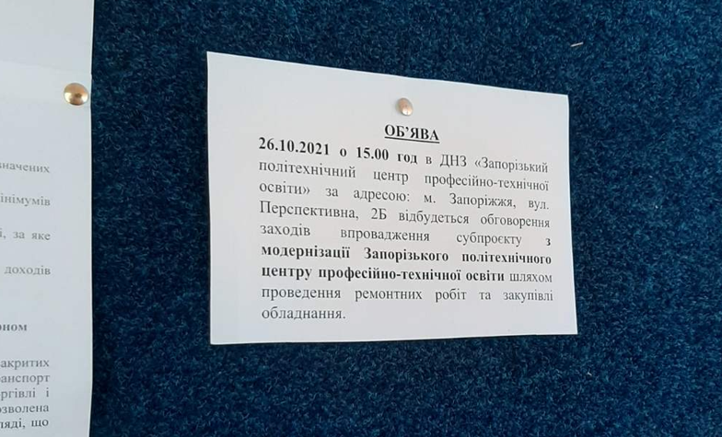
Placing announcements on the fronts of residential buildings No. 25, 29, 26/24, 33, 35 | 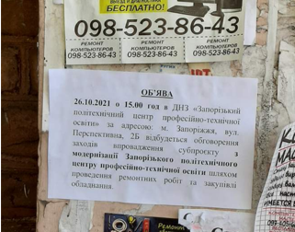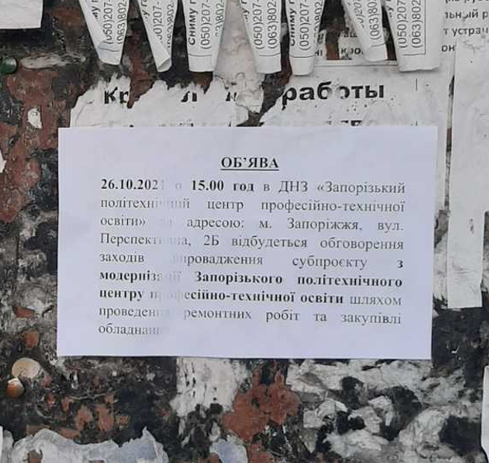  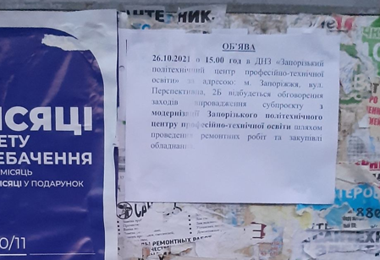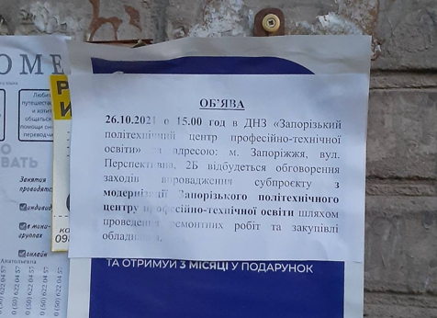  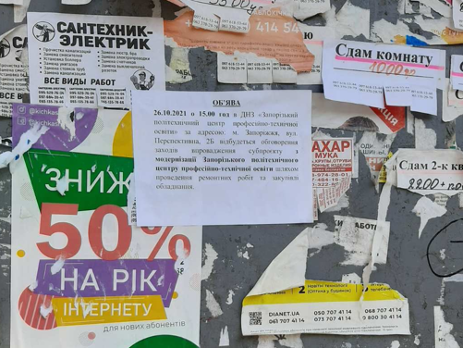
Placing announcements next to Social Shop | 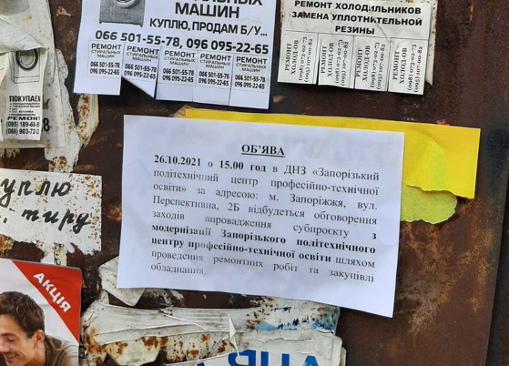
Placing announcements next to Primary Health Care Centre No. 4 and Zaporizhzhia regional anti-tuberculosis clinical dispensary | 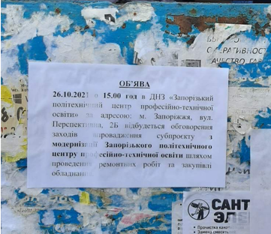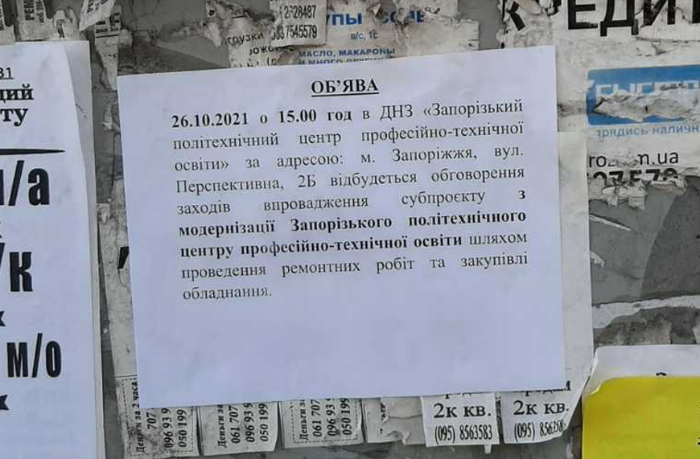

In order to fulfil the requirements of the Order of the Cabinet of Ministers of Ukraine No. 1236 of 09 December 2020 "On Quarantine and Restrictive Anti-Epidemic Measures to Prevent the Spread of Acute Respiratory Disease COVID-19 caused by SARS-CoV-2 Coronavirus in Ukraine", the public consultation took place in a mixed format (the main format was online on the Zoom platform with a partial direct presence of the participants in the premises of the Zaporizhzhia PCVE) in order to meet the safety requirements for preventing the spread of COVID-19. The consultation was attended by 69 people: representatives of the Zaporizhzhia PCVE: teaching and administrative staff, students and their parents. The results of the public consultation are summarised in the Minutes dated 26 October 2021, attached as Annex 2.

In order to determine the general attitude towards the SP, awareness of the SP measures as well as the level of satisfaction of educational and administrative staff and students of the Zaporizhzhia PCVE and their parents with the communication process regarding the SP activities, as well as their expectations regarding the results of the SP implementation in the period from 12 October 2021 to 29 October 2021, a survey was conducted among the educational and administrative staff (hereinafter referred to as teachers), students (hereinafter referred to as students) and their parents. A total of 55 teachers and 275 students took part in the survey.
The following conclusions can be drawn from the survey:
- In general, the SH are aware of the implementation of the SP and planned activities within the framework of the SP (teachers: 100% and 84.9% respectively; students: 85.2% and 78.5% respectively).

- Above 70% of teachers and students assessed the condition of the building of the institution as satisfactory, as requiring repair – about 20%, about 78% of students indicated that the equipment / machinery / tools needed renovation.

- More than 55% of teachers and 43% of students assessed the potential risks of the Project as low, slightly above 30% of respondents (33,3% teachers and 31% of students as moderate, 9,3% of teachers and 17,9% of students as significant risks and 2% of teachers and 7,7% of students as high risks.

- The most significant risk identified by both groups was the risk of inconvenience during the educational process (about 64% in total). This risk was associated with the main difficulties and inconveniences that could potentially arise during the implementation of the SP. Also among the risks that, according to the respondents, will generally occur during the implementation of the SP are the following: inconvenience due to increased noise levels, the formation of dust (total about 22% in total); inconvenience due to restricted access to a certain area or premises of the SP (about 22% in total); danger during construction works (about 18% in total); inconvenience due to the presence of unauthorised people on the institution's premises (about 11% in total); tension due to a lack of information about the SP (about 6% in total); an incomprehensible way of complaining about a particular inconvenience or danger (about 3% in total).

- More than 95% of teachers and 89% of students are satisfied with the communication with the implementers of the SP activities.

- The overwhelming majority of teachers surveyed consider the most acceptable means of communication to be the Zaporizhzhia PCVE website (67,3% of teachers and 40,6% of students), as well as in the matters of informing about the progress of SP implementation (about 80% of teachers and 64% of students), and the method of information disclosure is also the Zaporizhzhia PCVE website (about 83,3% of teachers and 72,1% of students).

- About 89,1% of the teachers and 83,8% of students surveyed are familiar with the SEP including GM, 76,4% of teachers and 78,9% of students understand the GM.

- Among the expectations indicated by teachers were: increasing the prestige of working professions and the image of the institution in general; attracting more applicants for vocational education; modernized educational institution with modern laboratories and modern equipment; improving the level of education; improving the digital literacy of teachers and students; significant improvement of working conditions.

- Among the expectations indicated by students were: improving learning conditions; equipment and tool upgrades; modernization of the institution; introduction of the newest technologies and innovations; introduction of new professions; internships and internships in Europe, with further employment; renovation of welding and metalwork workshops; raising the level of professional qualification of future specialists; gaining new skills.

After commissioning of the facility, a survey of the above-mentioned respondent groups is planned to determine the level of satisfaction with the SP activities implemented and the consistency of expectations with the actual results of the SP.

The disclosure process relating to the disclosure of Project documents will be implemented as follows:
- Disclosing the Stakeholder Engagement Plan, including the Grievances Mechanism on the websites of the USIF, Zaporizhzhia regional state administration and Zaporizhzhia PCVE for public discussion (was discussed on public consultation on October 26, 2021 and disclosed on USIF web-site on September 20, 2021, on Zaporizhzhia RSA web-site on September 20, 2021, on Zaporizhzhia PCVE web-site on October 12, 2021);
- Disclosing the version of ESIA (including ESMP) agreed by the KfW on the websites of the USIF, RSA and Zaporizhzhia PCVE for public discussion.
In order to reduce concerns and achieve a mutually agreed resolution of stakeholder grievances, the USIF has developed GM that is consistent with the level of potential risks and impacts of the SP.
According to the GM developed, grievances will be processed:
Responsible person at the level of the Zaporizhzhia PCVE: Andriy Mykhailovych Liush - Vice-Principal of the Zaporizhzhia PCVE for Educational and Productive Work,
tel. 095 586 58 84, e-mail: liushandriy@gmail.com
2-B Perspectyvna Street, Zaporizhzhia, 69009
http://zpcpto.zp.ua/prohrama-eu4skills.html
Responsible person at the level of the Project Implementation Team in the South-Eastern USIF RO (PIT): Galyna Antonivna El Hatri - Head of the PIT,
tel. 0671560100, e-mail: g.elhatri@usif.ua
Responsible person at the USIF CO level: Oleksandra Oleksandrivna Gryshko - Administrative and Integrity Consultant
tel. +38 (044) 356-65-50, e-mail: office@usif.ua.
https://usif.ua/

Further stakeholder engagement will take place in accordance with the Project Stakeholder Engagement Plan.

ANNEX 1
Subproject Screening Criteria
Checklist to complete and save

Facility name | State Educational Institution " Zaporizhzhia Polytechnical Centre for Vocational Education " (hereinafter referred to as Zaporizhzhia PCVE)
Address | Legal address: 2-B Perspectyvna Street, Zaporizhzhia, 69009  Address of the teaching block to be repaired: 2-B Perspectyvna Street, Zaporizhzhia, 69009.
Contact details | Full name - Andriy Mykhailovych Liush
 | Position - Vice-Principal of the Zaporizhzhia PCVE for Educational and Productive Work
 | e-mail: liushandriy@gmail.com | Tel. 095 586 58 84
Date of completion | 20 May 2021

No. | Criteria | YES | NO | If the answer is YES | If the answer is  NO | Note
1 | Does the institution have valid documents for carrying out its activities: licences, permits, etc.?  If not, please provide an explanation.  Permits subject to verification:  • a document certifying ownership / use of  the land plot and building | V  V |  | Implementation of the SP | Deviation of the SP | The land plot is communal-owned; the building is state-owned.
2 | Does the operating institution have or should have and is awaiting environmental permits? |  | V | ESMP | Implementation of the SP
3 | Will the subproject finance activities that will lead to an increase in works that will require environmental permits? |  | V | ESMP | Implementation of the SP
4 | Does the institution meet all the requirements of Ukrainian environmental regulations and normative documents regarding air emissions, water discharges and solid waste disposal?  If not, please provide an explanation | V |  | Implementation of the SP | Deviation of the SP
5 | Does the institution have any significant unpaid environmental fees, fines or penalties or other environmental liabilities (e.g. litigation pending regarding environmental issues, etc.)  If yes, please provide an explanation |  | V | Deviation of the SP | Implementation of the SP
6 | Will the implementation of the proposed activity result in the relocation of third parties, formal or informal occupation or use of land or buildings? |  | V | Deviation of the SP | Implementation of the SP | During the construction work, students will study in other classrooms of the school. The issue of organizing training in two shifts, in case there will not be enough classrooms, is also considered.
7 | Will the subproject activities generate wastewater and / or will environmental control measures be required to ensure compliance with current Ukrainian regulations? |  | V | ESMP | Implementation of the SP
8 | Will the subproject activities cause emissions into the atmosphere and / or will environmental control measures be required to ensure compliance with current Ukrainian regulations? | V |  | ESMP | Implementation of the SP | Due to dust generation
9 | Will the subproject activities cause noise levels that will require environmental control measures to ensure compliance with current Ukrainian regulations?  Will noise levels affect particularly vulnerable objects (natural environment, hospitals, educational institutions, community facilities)? | V | V | ESMP  ESMP | Implementation of the SP  Implementation of the SP | Yes, there will be noise, because the renovation work will be carried out inside a functioning educational institution
10 | Will the subproject use, store, produce, dispose of hazardous substances that:  • require special permits and licences;  • require licensed and specially trained personnel;  • are illegal or banned in the EU or Western countries;  • do not comply with the recommendations of the Pollution Prevention and Abatement Handbook (РРАН);  • may cause soil and water contamination if proper measures are not taken? | V |  | ESMP | Implementation of the SP | Yes, asbestos-containing materials
11 | Will the subproject generate waste requiring special disposal measures or the involvement of licensed organisations?  (if new equipment is purchased, will the old equipment be disposed of by an authorised licensed company or organisation?) |  | V | ESMP | Implementation of the SP
12 | Will the planned economic activity take place on or alongside protected areas / objects or such areas / objects whose status (granting a status) of protected areas / object is under consideration by the authorities? |  | V | Deviation of the SP | Implementation of the SP
13 | Could the work under this subproject have a potential impact on areas important to local or national cultural heritage? |  | V | Deviation of the SP | Implementation of the SP
14 | Is there any damage to the vegetation cover foreseen during the restructuring and refurbishment of the facility? |  | V | ESMP | Implementation of the SP
15 | Is there any damage to soil, land, landscape degradation foreseen during the restructuring and refurbishment of the facility? |  | V | Deviation of the SP | Implementation of the SP
16 | Have representatives of local communities or non-governmental organisations found concerns about the environmental aspects of the subproject or expressed objections to it? |  | V | ESMP | Implementation of the SP
17 | Is there any other aspect of the subproject that, under normal operating conditions or under certain circumstances, would entail risks, have a negative impact on the environment, the population or could cause inconvenience? |  | V | ESMP | Implementation of the SP
18 | Does the institution have any fines, penalties, significant recommendations due to inspections by local health and safety inspections or other obligations (e.g. litigation pending regarding health and safety issues, etc.)?  If yes, please provide an explanation |  | V | Deviation of the SP | Implementation of the SP
19 | Does the institution record and keep statistics on accidents and health and safety incidents? | V |  | Implementation of the SP | ESMP
20 | Does the institution monitor compliance with national health and safety legislation, EU regulations, organisational policies and standards? | V |  | Implementation of the SP | ESMP
21 | Is there any direct or indirect danger to public transport traffic and passengers during implementation of the subproject? | V |  | ESMP | Implementation of the SP
22 | Does the subproject restrict passenger / pedestrian access to commercial and shopping facilities? |  | V | ESMP | Implementation of the SP
23 | Is there an area available for storage of materials and  parking of vehicles intended for construction work on the existing site / are access roads provided? | V |  | Implementation of the SP | ESMP
24 | Are there any encumbrances on the location chosen for the construction / renovation work?  If yes, please provide an explanation |  | V | ESMP | Implementation of the SP
25 | Does the subproject require the purchase of private land? |  | V | Deviation of the SP | Implementation of the SP
26 | Is there any possibility that the subproject will result in any irreversible damage or loss of housing, other property, ability to use resources? |  | V | Deviation of the SP | Implementation of the SP
27 | Is there any possibility of evictions, business closures, commercial and livelihood activities during construction? |  | V | Deviation of the SP | Implementation of the SP
28 | Is there any temporary or permanent physical relocation of people due to construction? | V |  | ESMP | Implementation of the SP | During the construction work, training will be provided in other classrooms of the school
29 | Does the subproject provide for the relocation of people? If yes, please provide an explanation |  | V | Deviation of the SP | Implementation of the SP
30 | Will the population temporarily or permanently lose access to the means of production, services, natural resources? |  | V | Deviation of the SP | Implementation of the SP
31 | Will there be loss / damage to agricultural  land, unharvested crops, trees? |  | V | Deviation of the SP | Implementation of the SP
32 | Will the project lead to the loss of employment and jobs? |  | V | Deviation of the SP | Implementation of the SP
33 | Does the new construction work require additional /  qualified non-local labour? |  | V | ESMP | Implementation of the SP
34 | Will the subproject / construction activity cause disruption / concern to the local community? |  | V | ESMP | Implementation of the SP
35 | Will the construction of new buildings, drainage systems, power  lines cause any harm to public buildings /  resources / adjoining houses, wells, land, burial grounds,  children's parks, schools, etc.? |  | V | Deviation of the SP | Implementation of the SP
36 | Can the subproject cause such unpredictable consequences as accidents? | V |  | ESMP | Implementation of the SP
37 | Are there vulnerable population groups who may be adversely affected (including indigenous people) by the project activities? |  | V | Deviation of the SP | Implementation of the SP

ANNEX 2

PROJECT: EU4Skills: Modernisation of Vocational Education and Training Infrastructure in Ukraine
MINUTES
of public consultation on the subproject implementation
1 | Date and time of the consultation | 26 October 2021 at 15-00
2 | Subproject | Modernisation of the Zaporizhzhia PCVE infrastructure
3 | Place of the consultation | 2-B Perspectyvna Street, Zaporizhzhia, 69009
4 | Advisors / Moderators | By the Zaporizhzhia PCVE:  Polukhin Volodymyr Fedorovych, Director  By the USIF:  Galyna El Hatri, Head of the Project Implementation Team (USIF)  Tetiana Shcherbynina, Specialist in monitoring and evaluation, environmental and social issues
5 | Participants | 69 people
6 | Agenda | - Review of the purpose of public consultations  - Review of the projected activities: general information on the Project and Subproject, list of planned renovation measures and equipment purchases.  - Review and discussion of the expected environmental and social risks and impacts of the subproject described in the draft Environmental and Social Management Plan (ESMP), discussion of potential changes in the educational process.  - Review of the Stakeholder Engagement Plan, including the Grievance Mechanism: purpose of development, mechanism for submitting and reviewing complaints, persons responsible for the registration and review of complaints by schools and USIF.  - Discussion of the provided information, answers to questions.  - Review of useful links on the implementation of the subproject.
7 | Issues raised by community members during the consultation | Representative of the school: regarding the current progress of the project and the start of renovation work  USIF Consultant: the selection of the design developer is currently being completed, after signing the contract for about 3 months DED will be prepared, after receiving a positive expert opinion preparation and approval of tender documents will begin, then - the tender procedure for selection of the Contractor will be started

Zaporizhzhia PCVE Representative:
Director of the SEI "Zaporizhzhia PCVE" /signature/ V. Polukhin

USIF Representative:
Head of the Project Implementation Team /signature/ G.El Hatri

