USIF Supervisory Board endorsed the preliminary list of objects for implementation in the framework of USIF VI Project and approved the results of Ukrainian Social Investment Fund activities in the first quarter of the year 2019
Objects renovated under USIF V Project
in the first quarter of the year 2019
Dormitory with 80 places for IDPs renovated in Lviv
Before renovation | After renovation
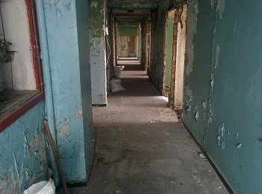 | 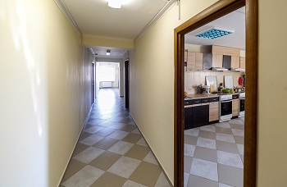
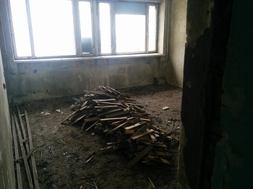 | 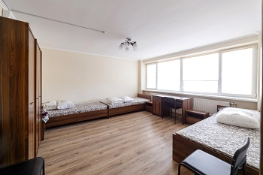
Kindergarten № 809, Kyiv: 125 additional places for children were created in 5 renovated group premises

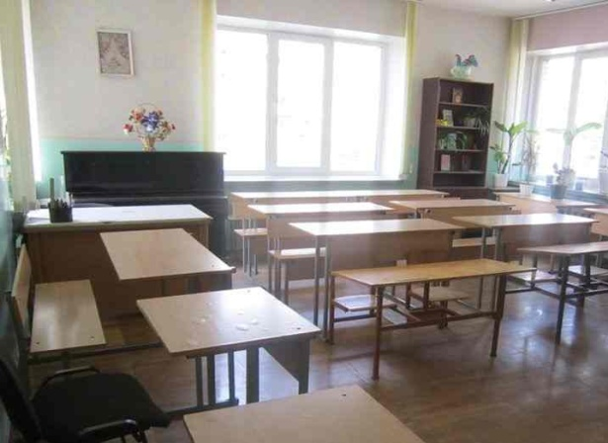 | 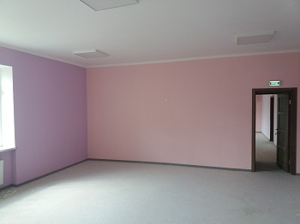
Kindergarten № 769, Kyiv: 75 additional places for children were created in 3 renovated group premises

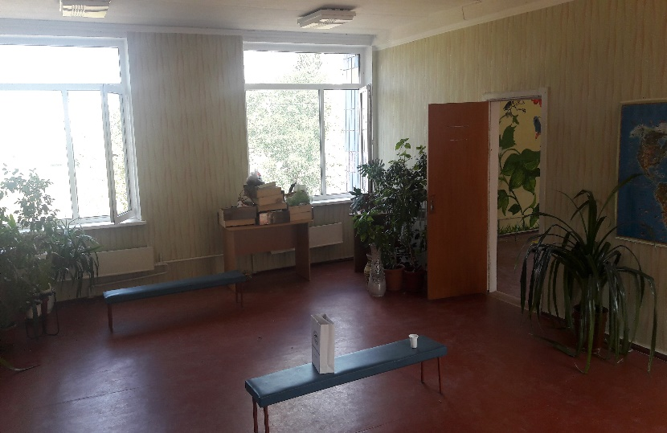 | 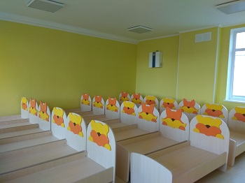
Kindergarten № 104, Kyiv: 100 additional places for children were created in 4 renovated group premises
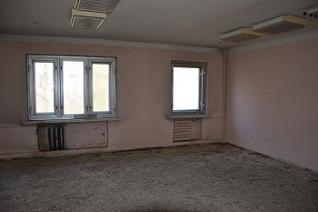 | 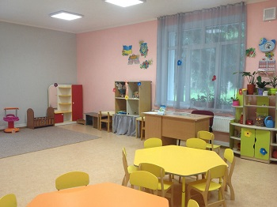
Boarding institution in Vovchansk, Kharkiv region: the building was completely renovated, energy saving measures were implemented

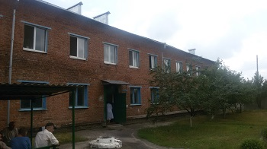 | 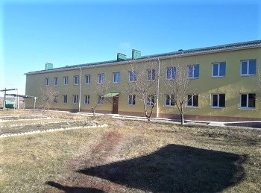
Preslav psychoneurological boarding institution, Zaporizhzhia region: the building was completely renovated, energy saving measures were implemented

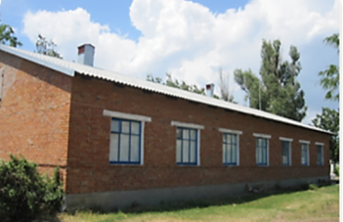 | 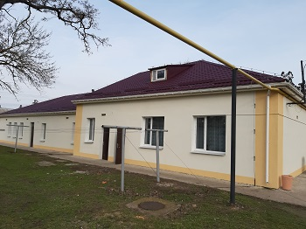
Dormitory in Zolochiv, Kharkiv region: the building with 24 rooms for accomodation of 55 IDPs was renovated
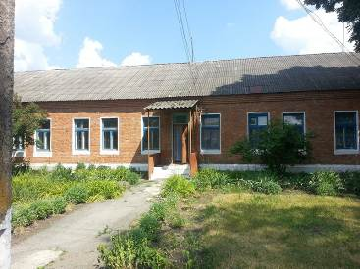 | 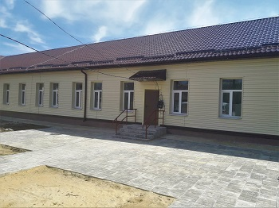
Apartment house in Pavlograd, Dnipropetrovsk region: the building with 19 apartments for accomodation of 40 IDPs was renovated

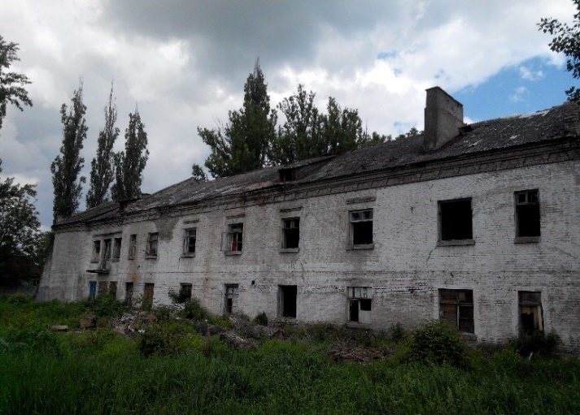 | 